# 1.Who collected the data?

Inside Airbnb (IA) is a website created by Murray Cox, the website offers for direct download data that is reportedly collected from Airbnb’s website. A variety of collaborators and partners contribute to Inside Airbnb, and it has an advisory board that assists to build sustainability for the project (*About*, no date).

# 2.Why did they collect it?

IA wants to provide data and advocacy about Airbnb's impact on residential communities (*About*, no date). IA wants communities to understand, decide and control the role of renting residential homes to tourists through data and information (*About*, no date).

# 3.How was the data collected?

# According to a page on IA’s website, the data is collected using python scripts, collecting public data from the Airbnb website. The collected data is verified, cleaned, analyzed and aggregated, and finally published on the IA website. IA will regularly update new data in each location (Alsudais, 2021).

# 4.How does the method of collection impact the completeness and/or accuracy of its representation of the process it seeks to study, and what wider issues does this raise?

The existing data was incomplete or inaccurate at both the key field and record levels:

According to the disclaimer on the IA website, the location information of the listings is anonymized, which means that the accurate location of the listings cannot be obtained, which will lead to accuracy problems in exploring the geographical distribution of the listings.

If the Airbnb platform deletes the listing information, the IA website may not be updated in time, resulting in information deviation.

IA data does not differentiate between reserved and unavailable rooms, so the unavailable status of a listing may not be accurate.

There are many missing values and values with wrong data types in the records of IA data.

The data collected by IA has obvious erroneous comments and no targeted identification. And this problem may become more serious as data increases.

# 5.What ethical considerations does the use of this data raise?

For transparency and accountability: all data is downloaded from official websites rather than being conducted by the team, so all data sources are annotated in detail, and specific information about the data is clearly visible on the respective websites.

For data storage and legal compliance, the team used onedrive for inter-team data sharing and storage, preventing unauthorised access and data leakage, which effectively facilitates the process of data handling within the team.

For avoiding bias and discrimination, the team collect data from credible official websites and process the data in a way that is objective, comprehensive and fair, taking into account the specific data of each borough in London.

For data accuracy, some limitations may exist in this data analysis. Since the rental prices were selected using a sampling method to calculate the average price, it cannot reflect the actual price comprehensively and realistically. Since the data came from two different websites, only five consecutive years of data could be collected, and the time-series limitation would affect the accuracy of future price prediction. In addition, the data included contains data from the covid-19 period, and sudden epidemic disasters may also have some effects on prices that exceed the rules of the market, affecting the analyses and judgements.

# 6. With reference to the data (i.e. using numbers, figures, maps, and descriptive statistics), what does an analysis of Hosts and Listing types suggest about the nature of Airbnb lets in London?

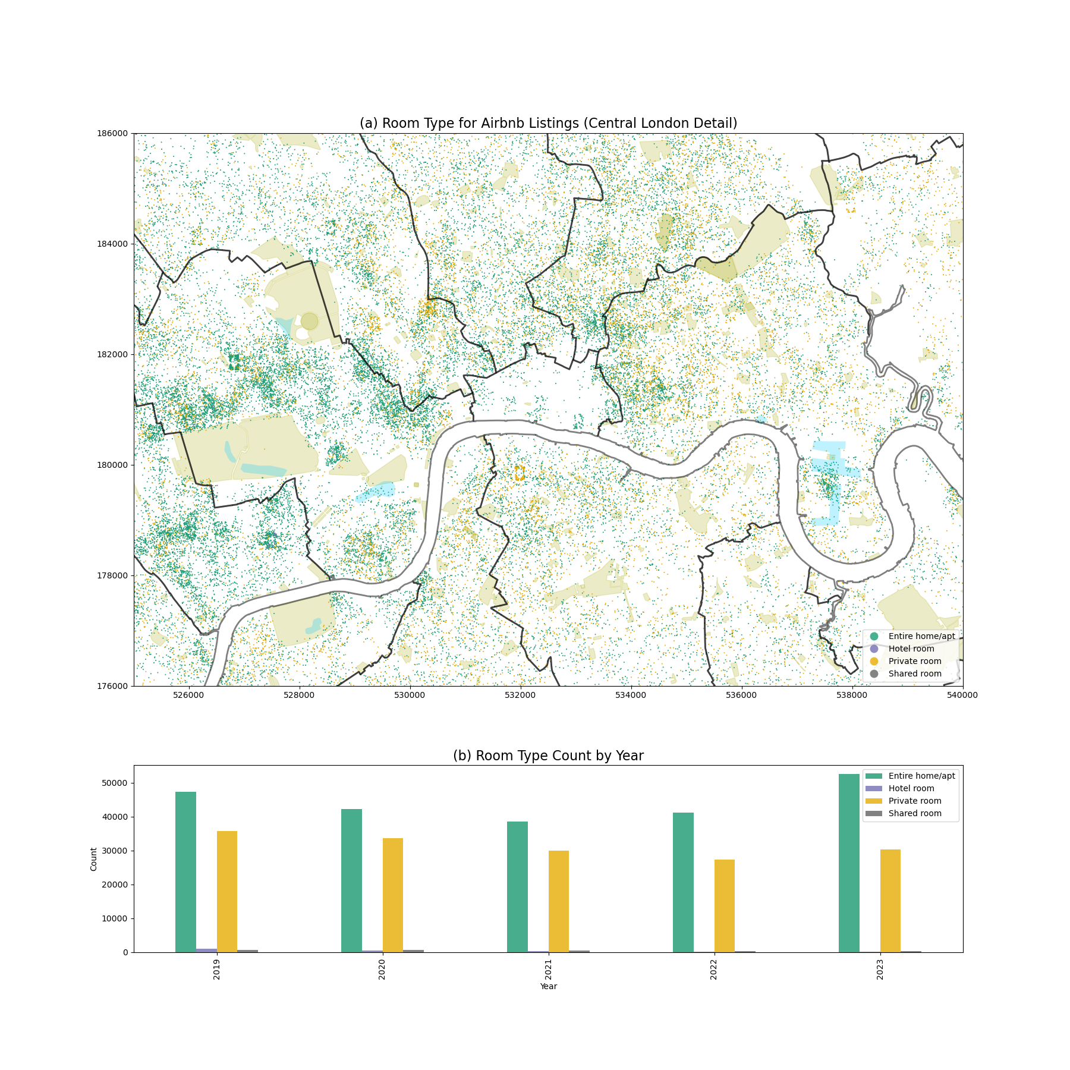

Figure：Room Type for Airbnb Listings and Room Type Count by Year

The bars in the figure mainly display the total number of listing types in the London region between 2019 and 2023, together with a map illustrating the distribution of listing types in 2023. The four listing types, "Entire home/apt", "Hotel room", "Private room", and "Shared room", are placed together north of the Thames. The most fully furnished residences are readily apparent and significantly more numerous than other types of accommodations, including hotel rooms. There are fewer rooms overall between 2019 and 2021; more rooms overall between 2021 and 2023, with a record-breaking 80,000 rooms in 2023.

According to Shabrina's (2021) literary reference, landlords in London are permitted to own a maximum of two properties annually, with a maximum rental length of 180 days per property. If either of these two rules is broken, it will be considered Airbnb abuse. According to data from the Airbnb website, there were 34,133 self-occupied landlords and 34,661 property-abusing hosts in London in 2020. By 2023, however, there will be significantly more property-abusing hosts—59,608—than self-occupied landlords (27,966). twice the amount.

We investigate the causes of this pattern. Short-term rentals may prove to be more profitable for property owners than long-term ones, thanks to rising market demand and financial incentives. This can lead some landlords to stray from the law in an effort to capitalise on the demand in the market.

Even with well-defined regulations, enforcing them might be difficult. For instance, a landlord might figure out how to get around the rules or might break them because they don't know about them or don't comprehend them. According to the survey, 86% of landlords stated they would go above and above to learn about pertinent rules and guidelines. Based on this, it can be assumed that some landlords are aware of the rules but don't always follow them, or have even figured out a method around them (Marcus, 2022).

In addition, Airbnb established a 90-day yearly booking limit in 2017 for listings that are not controlled on the platform (Airbnb, 2020). Over time, there haven't been many changes made to this regulatory framework in London (Dorine, 2021). It is assumed that regulatory bodies might not have the resources necessary to properly implement these regulations or that landlords are not promptly informed of any updates to the policy (Zahratu, 2021).

# 7. Drawing on your previous answers, and supporting your response with evidence (e.g. figures, maps, and statistical analysis/models), how could this data set be used to inform the regulation of Short-Term Lets (STL) in London?

As international students in the UK, the team members have experienced the increasing cost of renting a property in the London area, making it harder to rent a suitable property every year. Concerning the growing Airbnb market, they wanted to explore the impact of short-term lets such as Airbnb on the long-term rental market. After extensive literature reading, the team members found that the rent of long-term rentals in the UK increases with the number of Airbnb listings [1]. It's comprehensible that Airbnb as a short-term rental would impact the same short-term rental industry as the hotel industry, but why would it also affect long-term rentals with a different audience? A phenomenon in Berlin, a European city, answered the team members' questions very well. The housing stock in the city will not change drastically in the short timeframe. Still, many platforms and landlords are transforming flats or redundant housing that were initially put on the long-term rental market into short-term rentals by placing them on Airbnb for a higher profit. This behavior has led to an increase in the number of Airbnb listings and a decrease in the number of long-term rentals, which has directly led to a reduction in the supply of long-term rentals and an increase in long-term rentals [2]. Airbnb impacts the long-term rental market in different cities worldwide, especially in some tourist cities. [3] In this context, we want to explore whether Airbnb similarly impacts long-term rentals in the London area qualitatively and quantitatively. Accordingly, we set out to answer the following 4 questions:

1. The effect of London.airbnb's listing density on long-term rental rents.

2. The effect of London.airbnb's price on long-term rental rents.

3. What is the effect of the increase or decrease in the price of Airbnb in different regions on the rise or decrease in the rent of long-term rental properties?

4. the effect of the rise and fall of Airbnb density in different regions on the rise and fall of long-stay rents.

The findings in this report are based on a rigorous analysis of the period 2020-2023, focusing on London's 33 boroughs. In addition to the IA's data, we downloaded average monthly rents for long-term rentals in each borough of London from the office for national statistics website for comparative research. In terms of region and year boundaries, we processed more than 400,000 pieces of Airbnb data and nearly 10,000 pieces of sampled data of long-term rentals in each London borough and cleaned, screened, filtered, grouped, type-converted, consolidated, and computed all the data using the tools such as pandas, pandas, and numpy. Rents were calculated using the following formulae.

**Visualization of key components:**

To have a more intuitive look at the price distribution characteristics of Airbnb listings and long-term rental listings, a visualization of the presentation of the values is plotted as shown in the figure below. As shown in figure a, the closer to central London, the greater the kernel density of Airbnb listings. From the specific area density graph b, it can also be seen that the distribution of Airbnb, in general, shows a pattern of the closer the area is to the center of London, the denser the Airbnb is; the borough with the highest Airbnb density is Kensington and Chelsea, the next borough is Westminster. From figure c, Airbnb price is also broadly similar to the density distribution, with the highest priced borough being Kensington and Chelsea, followed by Westminster. However, Airbnb price is only partially determined by density. For example, the third highest-priced borough is Barking and Dagenham, which is likely related to other factors such as national urban regeneration policies [4]. Surprisingly, a similar trend was observed in long-term rentals and Airbnb density distribution, as seen in figure d. The highest-priced boroughs are Kensington and Chelsea, followed by Westminster. After visualizing this, the team used panel data to demonstrate the further relationship between the two.

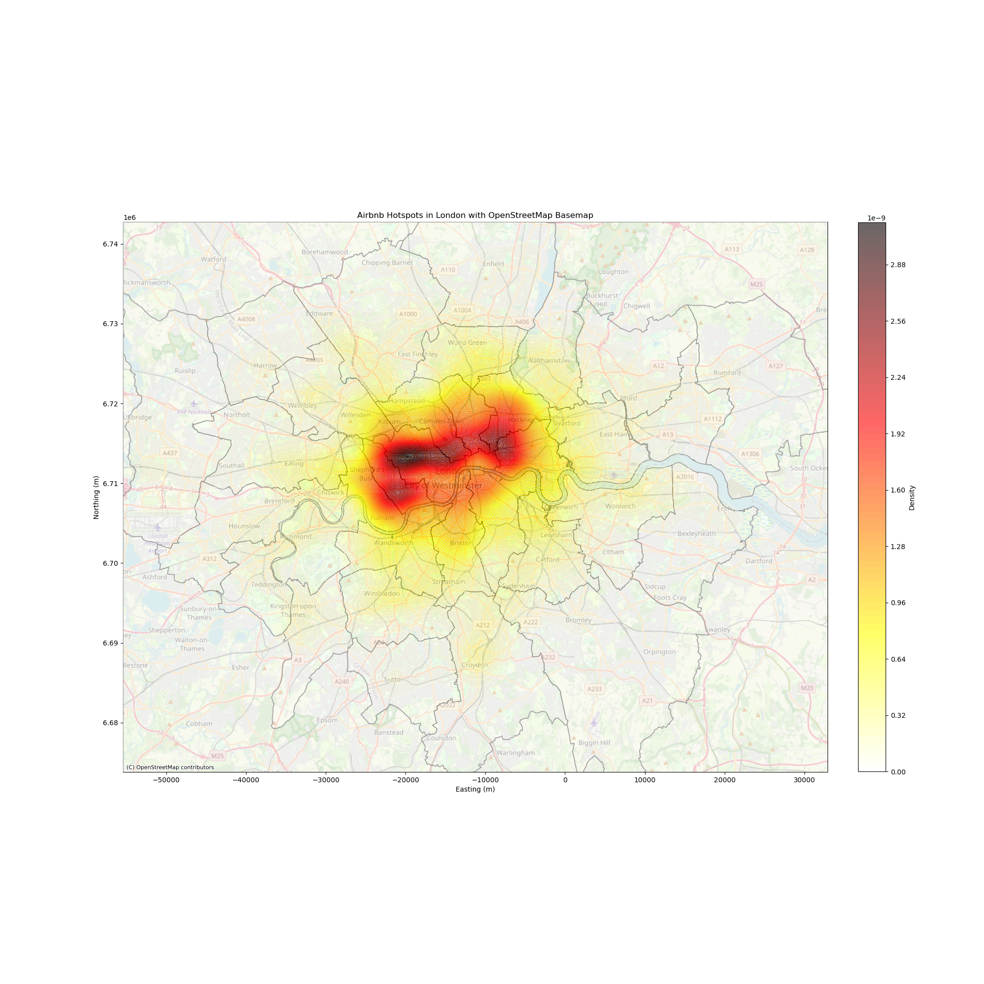

Panel Data

As this processing involves data collected from four consecutive years of Airbnb and long-term rentals, the team decided to use panel data to analyze and present the results. Panel data combines time series and cross-sectional data, which is an efficient trinomial data structure. It allows us to explore the evolution of the three eigenvalues we need over four years and over time. Based on this, the team performed regression calculations using a random effects model (RE). This can be seen in the figure : The R-squared value of 0.8569 indicates that the model explains about 85.69% of the variance in the dependent variable. The F-statistic of 484.96 is very high, meaning the model is statistically significant. The associated p-value is 0.0000, which is less than 0.05, so we can reject the null hypothesis that all model coefficients are zero (i.e., the model has predictive power). Combined with the actual long-term rental problem analyzed, the random effects model shows that Airbnb price and density have a significant positive effect on long-term rental prices. The high R-squared values indicate that the model fits the data well and that the data structure appears to be balanced with consistent observations across entities and periods.

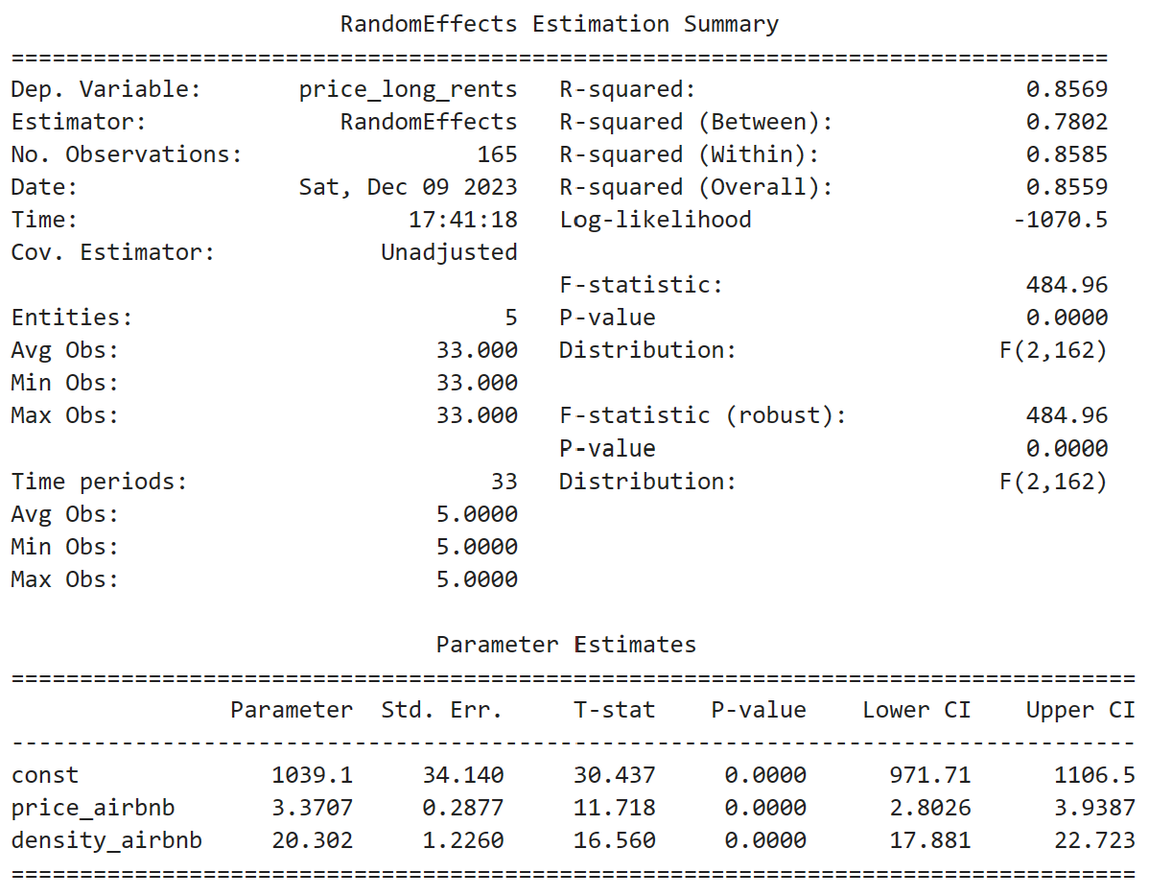

The conclusions presented from the panel data verify the hypothesis we have previously put forward: The London Airbnb market landlords consist of individual and company platform-based landlords. Due to the enormous benefits of Airbnb short-term rentals, many long-term rental landlords have withdrawn their houses from the long-term rental market and put them into the Airbnb short-term rentals platform. This behavior has directly caused an increase in the density of Airbnb listings in all areas of London in the short term. Analyzing the data from 2020-2023, it is clear that the increase in Airbnb prices significantly impacts long-term rentals in boroughs where demand is higher. For example, in Kensington and Chelsea borough, a 1% increase in Airbnb prices is associated with a 0.5% increase in long-term rentals. In contrast, in Islington borough, where demand for residential accommodation is high, a 1% increase in Airbnb prices is associated with a 30.1% increase in long-term rentals. From this analysis, people living in residential areas have a higher demand for long-term rentals. Under the condition that the total number of properties remains roughly the same, landlords will convert long-term rentals into Airbnb listings, resulting in the supply of long-term rentals exceeding the demand for long-term rentals in the long and short term, which will lead to a more significant increase in the price of long term rentals. Meanwhile, by analyzing the impact of rising Airbnb density on the price of long-stay rentals, the team found that for every additional listing in London boroughs by Airbnb, the price of long-stay rentals subsequently increased by £2. The lower the density of the London boroughs, the more the price of long-term rentals is affected by Airbnb density. For example, in Kensington and Chelsea borough, which has the highest density of Airbnb, the price of long-term rentals increased by 9.5% for every 1% increase in Airbnb density; in Ealing borough, which has moderate Airbnb density, the price of long term rentals increased by 32.9 percent for every 1 percent increase in Airbnb density; in Sutton borough, which has a low density of Airbnbs, the price of long-term rentals increased by 69.3%for every 1% increase in Airbnb density. From extensive research surveys, it can be surmised that areas with higher Airbnb densities are regulated by stricter policies, while areas with lower Airbnb densities are more laxly regulated. [5] Despite the same regulations, the laxity of regulation and enforcement has resulted in the price of long-term rentals being disproportionately affected by the increase in the number of Airbnb's, thus resulting in excessive rental growth.

Suggestions:

Based on the above findings， the following four recommendations are made according to the actual situation of London's Airbnb market and long-term rental market:

1. For the Airbnb platform: Limit the number of listings placed on the Airbnb platform by the same landlord. In the case of individual landlords, the number of properties owned by the individual is limited, and the number of properties placed on Airbnb is also limited. Suppose it is a second-hand landlord or a company that operates them. In that case, they will rent many properties and then put them on Airbnb, which is more prominent in scale and drastically impacts the long-term rental housing market. Therefore, if the Airbnb platform can strictly review the landlord's information and limit the number of listings, it can help the healthy development of the Airbnb platform.

2. For the Airbnb platform: Raise the threshold for hosts to register on the Airbnb platform. Restricting every set of in-Airbnb hosts to being the actual house owner—crack down on speculation by second homeowners in the name of companies or individuals.

3. For government departments: improve regulation. Although London enacted a new round of regulatory rules in 2017, there is a thicket of regulation, resulting in long-term rentals being hit harder by Airbnb in boroughs where the density of Airbnb listings is lower.

4. For government departments: according to the specificity of each borough, stipulate the number of new Airbnb allowed within a year. For example, residential areas far away from scenic spots should be prioritized to protect the living needs of residents.

This report also has some limitations. The data collected in 2020-2023 includes the data during the epidemic. The epidemic has had a significant impact on the tourism industry Airbnb, which makes the price and density of Airbnb have a particular deviation, resulting in the conclusion that may not be entirely in line with the law of the market. The data on long-term rentals are obtained from the official website. Still, the data of the official website is obtained by sampling, which leads to the data needing to reflect the current situation of the long-term rental market. Secondly, when exploring the impact of Airbnb on the rent of long-term rentals, there are too many factors affecting the rent, such as inflation, population mobility, and national policies, which makes the increase in the rent of long-term rentals in our study may not be entirely caused by the Airbnb market.

Appendix

Reference:

[1]https://ci.carmel.ca.us/sites/main/files/file-attachments/harvard_business_article_and_study.pdf

【2】[The Effect of Home-Sharing on House Prices and Rents: Evidence from Airbnb (informs.org)](https://pubsonline.informs.org/doi/epdf/10.1287/mksc.2020.1227)

【3】 https://www.researchgate.net/profile/David-Neeser/publication/282151529_Does_Airbnb_Hurt_Hotel_Business_Evidence_from_the_Nordic_Countries/links/5605310e08aea25fce322679/Does-Airbnb-Hurt-Hotel-Business-Evidence-from-the-Nordic-Countries.pdf

【4】

<https://citeseerx.ist.psu.edu/document?repid=rep1&type=pdf&doi=c624a793606739b3af246d50f9506cfdd03e383d>

【5】

https://papers.ssrn.com/sol3/papers.cfm?abstract_id=3676909

[Airbnb及其对伦敦房地产市场的潜在影响 - 扎赫拉图·沙布丽娜、艾尔莎·阿考特、迈克尔·巴蒂，2022 年 (sagepub.com)](https://journals.sagepub.com/doi/full/10.1177/0042098020970865)

[Airbnb 法规的演变 – COVID-19 之前、期间和之后的 Airbnb (pressbooks.pub)](https://uq.pressbooks.pub/airbnb-978-1-74272-321-1/chapter/the-evolution-of-airbnb-regulations/)

[驯服本地Airbnb：分析阿姆斯特丹，柏林和伦敦的法规 - Hübscher - 2023 - Tijdschrift voor Economische en Sociale Geografie - Wiley在线图书馆](https://onlinelibrary.wiley.com/doi/full/10.1111/tesg.12537)

[[1903.11205] Airbnb对伦敦住房结构的破坏 (arxiv.org)](https://arxiv.org/abs/1903.11205)

Reference

*About*. (no date). Available at: http://insideairbnb.com/about/ (Accessed: 19 November 2023).

Alsudais, A. (2021). ‘Incorrect data in the widely used Inside Airbnb dataset’. *Decision Support Systems*, 141, p. 113453. doi: 10.1016/j.dss.2020.113453.